Oltp vs Olap
Oltp :- Online transaction Processing
Olap:- Online Analytic processing
Oltp is generally for data in where as olap is for information out.
Oltp is used for operational based system where as olap is used for analytics purpose.
Oltp has both read/write operations where as olap is for read as oltp has only current records upto 100 while olap has millions of data records.
Size of olap is in tera byte.
Size of oltp is in giga byte.
Oltp is accessed by anyone where as olap is accessed only by specific knowledge people ie analyticals peeps.
Eg:-
Oltp
ATM
Bank Transaction
Olap
Trends on social media to analyse the data.
Recommendation to customers like Netflix recommending a film on based of previous movie watched by a user.
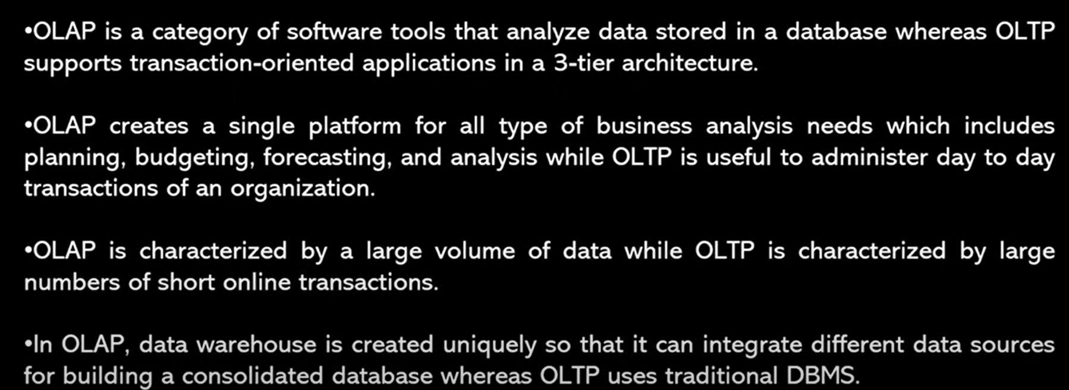
Conclusion via differences
